For sale

2008 Four Winns Horizons 220. Volvo Penta 5.7 GI V8 with 270 HP (300 hours). This is a 22' bow rider. The boat comes with a bimini top, aft folding bench/lounge cushions, removable table and full cover set (mooring and fore and aft cockpit covers). AM/FM Stereo. The boat runs and cruises around 30; with a top speed around 50 MPH.
The interior is original and shows little wear. The overall condition is good to excellent.
The boat is 22' in length with an 8'6" beam. It weighs about 3,800 dry.
No trailer.

Currently in water on Deep Creek Lake, Swanton, MD. Freshwater use only.
Asking $19,000 (NADA low retail $21,290) No delivery

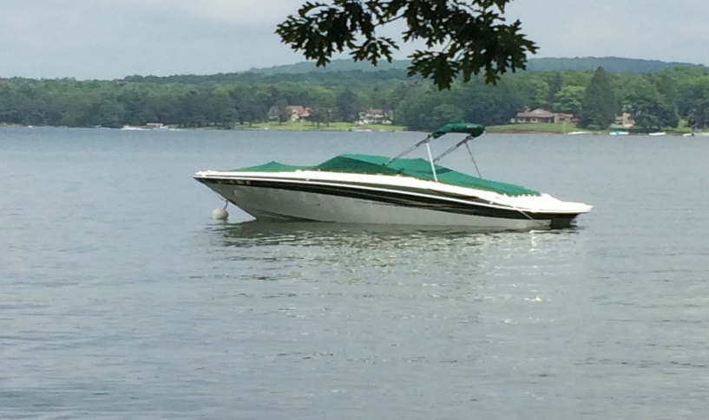
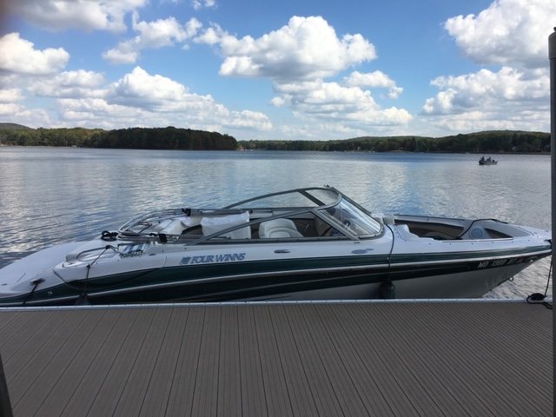
Contact:
J. Becker
202-390-8728
Johnb377@ Verizon.net

